Engaging Students Through Design

BANNER

Banner Attributes
1100 x 200 pixels
Width = 100% of screen space (responsive)

Example Code
<img style="width: 100%;" src="https://canvas.seattlecentral.edu/courses/1779143/files/114407990/download" alt="Course Banner: Intermediate Canvas">

Heading 2

Heading 2 Attributes
Red Background: #ca2017
Solid Black Bottom Border: #000
Width = 100% of screen space (responsive)
Height = 48 pixels
Line-height = 200%
White Text: #ffffff
Font-Size: x-large
Font-weight: bold

Example Code
<h2 id="Navigation" style="margin: 20px 0 20px 0; border-bottom: 5px solid #000; width: 100%; height: 48px; text-align: center; line-height: 200%; font-size: x-large; font-weight: bold; background-color: #ca2017; color: #ffffff;">On This Page</h2>

Button
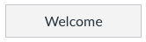

Button Attributes
Width = 125 pixels
Margins: Top: 5 pixels Right: 5 pixels Bottom: 5 pixels Left: 5 pixels
Grey background: #f5f5f5
1 pixel, Solid Grey Border: #c7cdd1

Example Code
<a id="Welcome_button" style="width: 125px; margin: 5px 5px 5px 0; background: #f5f5f5; color: #2d3b45; border: 1px solid; border-color: #C7CDD1; display: inline-block; position: relative; padding: 8px 14px; margin-bottom: 0; font-size: 1rem; line-height: 20px; text-align: center; vertical-align: middle; cursor: pointer; text-decoration: none; overflow: hidden;" href="#Welcome">Welcome</a>

Content Container
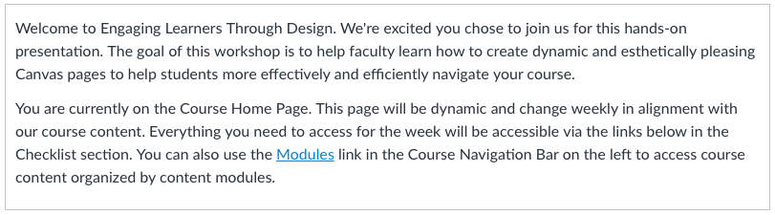

Button Attributes
1 pixel, Solid Grey Border: #ccc

Example Code
<div id="Welcome_Container" style="padding: 0px 10px 10px 10px; border: solid #ccc 1px; overflow: hidden;">

<p>Welcome to Engaging Learners Through Design. We're excited you chose to join us for this hands-on presentation. The goal of this workshop is to help faculty learn how to create dynamic and esthetically pleasing Canvas pages to help students more effectively and efficiently navigate your course.</p>
</div>

